Implementation of MQTT Protocol for Wireless Monitoring of Industrial Drives

Using Internet of Things Technology

N. Neelabalan 1, M. NAVEEN KUMAR 1,

L. HARIHARAA SUDAN 1

1*Easwari Engineering College, Chennai*

2*ekn.eee@gmail.com*

*[1]Abstract*— Electrical motors and drives consumes about 45% of the power generation. However, if the electrical machines are not maintained properly it will lead to discontinued production which may affect the productivity and revenue. Continuous monitoring of critical parameters of various machines and drives is crucial [18] for an industry which operates large number of machines continuously. Before the advent of Internet of Things (IoT) technology, monitoring of the machine parameters were carried out using Supervisory Control and Data Acquisition (SCADA), which can store data only to a certain extent, after which that data will be overwritten by more recent data. Also the online monitoring of the machine is not feasible. However, in IoT technology the collected data can be stored online and integration with all cross platform applications can be done which benefits the end user by cutting down huge investment costs [9]. In the proposed work, current, voltage, speed and number of working hours of the 3 phase AC motor in the laboratory are monitored. These parameters are sensed by the current transformer, potential transformer and Hall effect sensor respectively. The data is collected and processed using microcontroller and transferred to a remote server wirelessly using Message Queuing Telemetry Transport (MQTT) protocol [2]. The received data is then sent to the telegram server. Any deviation from the rated operating conditions is reported to the concerned person through chat bot in telegram mobile app [6].

*Index Terms*— Chat Bot, IoT, Machine, MQTT, Sensors

# Introduction

## General

With the rise in automation in recent times electrical machines in industries are rising at a rapid pace. These machines need to be taken care of effectively for healthy operation in the long run. For that to happen, we need to monitor all the machines with limited or no man power and this requires effective and efficient monitoring from any place and from any device.

In the first three industrial revolutions, humans have created mechanical, electrical and information technology, which were aimed at improving productivity and efficiency of industrial processes. The first industrial revolution improved efficiency through the use of hydropower, steam power and development of machine tools. The second industrial revolution brought electricity and mass production and the third industrial revolution further accelerated automation using electronics and information technology. Now the fourth industrial revolution is emerging which is led by Cyber-Physical system (CPS) technology to integrate the real world with the information age for future industrial development. In order to cope up with the Industry 4.0 [1] many industries are adopting newer cutting edge technologies such as Machine learning, Deep neural networks, Block chain and Internet of Things.

In the mid-20th century the electrical machine's parameters were monitored manually and individually for every single machine by the operator. Manual monitoring had many shortcomings like error in readings and reporting of the error took a very long time.

Then in the early 1980s, SCADA (Supervisory Control and Data Acquisition) became very popular which aided in monitoring and control of electrical machine parameters. SCADA is an end-to-end system that receives data from Intelligent Electrical Devices (IEDs) or Remote Terminal Units (RTUs), which are connected to sensors through a communications network. The system then analyses this data and sends commands back to the field, with individual SCADA applications often working simultaneously.

Even though SCADA systems have been doing a great job in monitoring and controlling industrial and facility-based processes that exist in the physical world, processing of data and integration of artificial intelligence is not possible in the traditional SCADA.

Later in the early 90’s, many industries started adopting monitoring of electrical devices and alerting the user through SMS. With this method data collection is very limited and also is tedious. Moreover, the amount of power consumed by these devices were also high. By adopting to Internet of Things technology, the communications methods and protocols such as Long-Range Wide Area Network (LoRaWAN), low energy Bluetooth and MQTT protocol that are easy to setup and consumes very less power with efficient data collection. Thus IoT is the best platform for lower power consumption and data transfer more efficiently and effectively.

## Internet of Things

As an emerging technology, the Internet of Things (IoT) offered promising solutions to revolutionize the operation of many existing industrial control and monitoring systems. IoT is related with more technologies such as sensors, actuators, GPS devices, and mobile devices. Today, a commonly accepted definition for IoT is a dynamic global network infrastructure with self-configuring capabilities based on standard and interoperable communication protocols where physical and virtual ‘Things’ have identities, physical attributes, and virtual personalities and use intelligent interfaces, and are seamlessly integrated into the information network. Internet of Things technology has recently gained traction for its low power and wireless connectivity of machines to central or distributed server. IoT technology has innumerable applications in home automation, consumer electronics and other industrial automation sectors with great success at minimal cost/investment. IoT technology enables integration of other Information Technology concepts like machine learning, deep neural network, block chain etc. for efficient predictive maintenance of the machines. The four stages of Industrial revolution is showed in Figure 1.

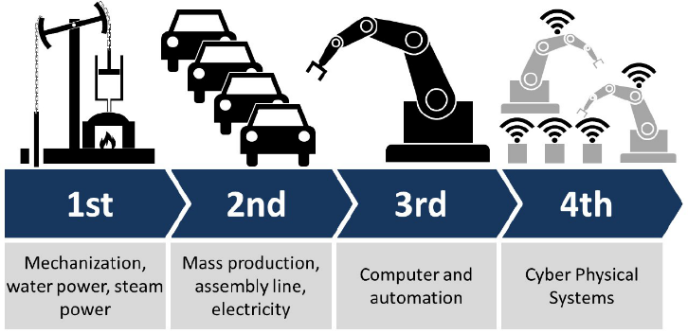

Fig. 1. Four stages of Industrial Revolution

## MQTT Protocol

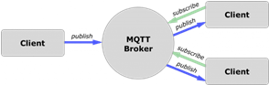

Fig. 2. MQTT Protocol

MQTT (Message queue Telemetry Transport) is a publish/subscribe, extremely simple, flexible [11], easier to implement [16] and lightweight messaging protocol, designed for constrained devices [3] and low-bandwidth, high-latency [4] or unreliable networks. The design principles are to minimize network bandwidth and device resource requirements whilst also attempting to ensure reliability and some degree of assurance of delivery. These principles also turn out to make the protocol ideal of the emerging “machine-to-machine” (M2M) or “Internet of Things” world of connected devices, and for mobile applications where bandwidth and battery power are at a premium. MQTT protocol can also be implemented over Ethernet but to avoid the hassle of wires, Wi-Fi is being used. [7]. The MQTT communication system uses a publisher subscriber model. A client may be either a publisher or subscriber. A topic is created by the publisher to which the client subscribers. The publisher and the subscriber are connected to a broker. All messages are routed through this broker. The Raspberry Pi [20] runs the Eclipse Mosquitto broker and also acts as a subscriber to the topics published by the NodeMCU client [19]. Here we consider the NodeMCU to be the publisher which publishes the sensor data to the corresponding topics created by it. The Raspberry Pi acts both as subscriber and broker. The Raspberry Pi subscribes to these topics and sends these messages to the telegram chat bot server [8].Figure 2 shows the concept of MQTT protocol.

## Comparison between HTTP and MQTT protocols

Table 1. Comparison table [21]

|  |  |  |
| --- | --- | --- |
| **FEATURES** | **MQTT** | **HTTP** |
| Design Methodology | The protocol is data centric. | The protocol is document centric. |
| Complexity | Simple | More complex |
| Data security | Yes | No, hence HTTPS is used to provide data security. |
| Message size | Small, it is binary with 2-byte header. | Large, it is in ASCII format. |
| Service levels | 3 | 1 |

Compared to HTTP protocol MQTT can handle larger payloads in shorter time making it a better solution for usage in IoT technology [3]. The setting up of bidirectional communication between sensor nodes is also easier compared to HTTP [5].

# Design and Workflow

## Power Supply

There are three power supply connections involved in this project. One is for the signal conditioning circuit, multiplexer and opto-isolator (level shifting) combined. The second one is for the microcontroller board and the accompanying ADS1115 board which works in the logic level of 3.3 V. The third supply is a 3 phase AC supply for the motor which is 415 V (220 V ph-ph).

The power transformer of rating 415 V/15 V with center tap gets a supply voltage of 230 V and this supply can be drawn from the mains. The transformer steps down the voltage down to +9 and –9 V [10]. The +9 V and –9 V AC supply from the transformer secondary is provided to bridge rectifier IC DB104. The output of DB104 is a DC voltage of + 5.34 V and – 5.34 V considering the potential drop across the 4 diodes. The positive and negative output of the bridge rectifier IC is fed as input to the voltage regulator ICs LM7805 (positive supply) and LM7905 (negative supply). A rectifier output voltage of +5 V and -5 V are obtained at the output of LM7805 IC and LM7905 IC respectively.

The NodeMCU board receives 5 V supply though micro USB cable from a mobile charge adapter. The 5 V is regulated to 3.3 V internally in the board using the AM1117 IC. The opto-isolator which is being used here as a level shifter get both 5 V and 3.3 V supply from the LM7805 IC and 3.3 V supply from the NodeMCU board. The level shifter is being used to select the pins in the multiplexer (cd451).

## Signal Conditioning Element

Among many methods that are being used to monitor the current and voltage of a device, using a current and potential transformer is preferable because it is an easy and cost effective method. The current transformer is easy to install and susceptible to very less mechanical changes compared to LEM sensor. The potential transformer is a better method to measure AC voltage compared to using potential divider and then using a precision rectifier to measure the voltage.

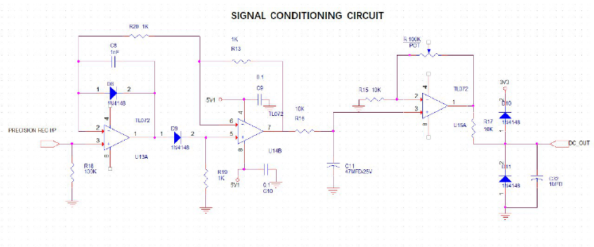

Fig. 3. Signal Conditioning Circuit

The signal conditioning circuit shown in Figure 3 is required to convert the AC signal that is being received from the current sensor and potential sensor to DC voltage levels. A precision rectifier circuit being used here which convert the peak to peak AC voltage to DC voltage and remove noise from the signal if any found. The precision rectifier circuit uses the OP-amp IC LM324.

## Multiplexer

The CD4051 is a CMOS single 8-channel analog multiplexer/demultiplexer with logic level conversion. Analog input of 20V peak-peak and can supplied. The multiplexer receives input from the 3 current transformer and 3 potential transformer. The input to three channels namely A, B and C are provided from the NodeMCU GPIOs.

## NodeMCU

NodeMCU is a Wi-Fi SOC (system on a chip) based on ESP8266 -12E Wi-Fi module. It is a highly integrated chip designed to provide full internet connectivity in a small package. It can be programmed directly through USB port using various programming languages [12].

The selection of the sensor output through the common output pin is done through setting high and low logic levels through GPIOs of the NodeMCU. The suitable current or voltage sensor’s input to the ADC can be selected from the MCU. The 3.3 V to 5 V level shifter is used to select the channels in the multiplexer. The output of the multiplexer is connected the ADS1115 (analog to digital converter) and the digital values is being read by the MCU using I2C from the defined address in the EEPROM.

$$Motor Voltage=\frac{450*ADC Count}{ADC Upcount }$$ $$where ADC Upcount=32768 \left(for 16-bit ADC\right) (1)$$

The ADC count in the above equation (1) refers to the digital value received for the corresponding analog value of the measured voltage.

$$Motor Current=1.5*\frac{ADC Count}{ADC Upcount}$$ $$where ADC Upcount=32768 \left(for 16-bit ADC\right) (2)$$

The ADC count in the above equation (2) refers to the digital value received for the corresponding analog value of the measured current. The actual voltage and current values are measured using the equations (1) and (2) respectively.

## Hall Sensor

The hall sensor [2] is being used here to measure the speed at which the motor shaft rotates. A hall effect latch sensor pulses upon reaching the proximity of a magnet that is attached at the rear part of the rotor. The output of the hall sensor is connected to D5 of the NodeMCU GPIO.

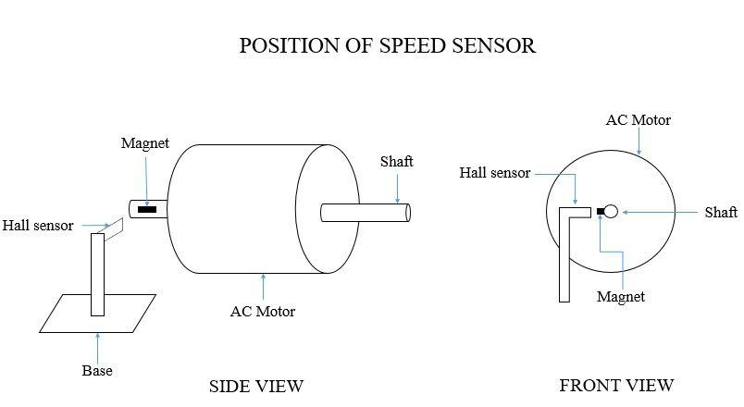

Fig. 4. Position of Speed Sensor

The D5 is configured in input mode. Every pulse of 3.3 V received at the output of the hall sensor is counted and divided by 60 to produce the RPM. The hall sensor is fitted like as shown in the Figure 4. The overall workflow is shown in Figure 5.

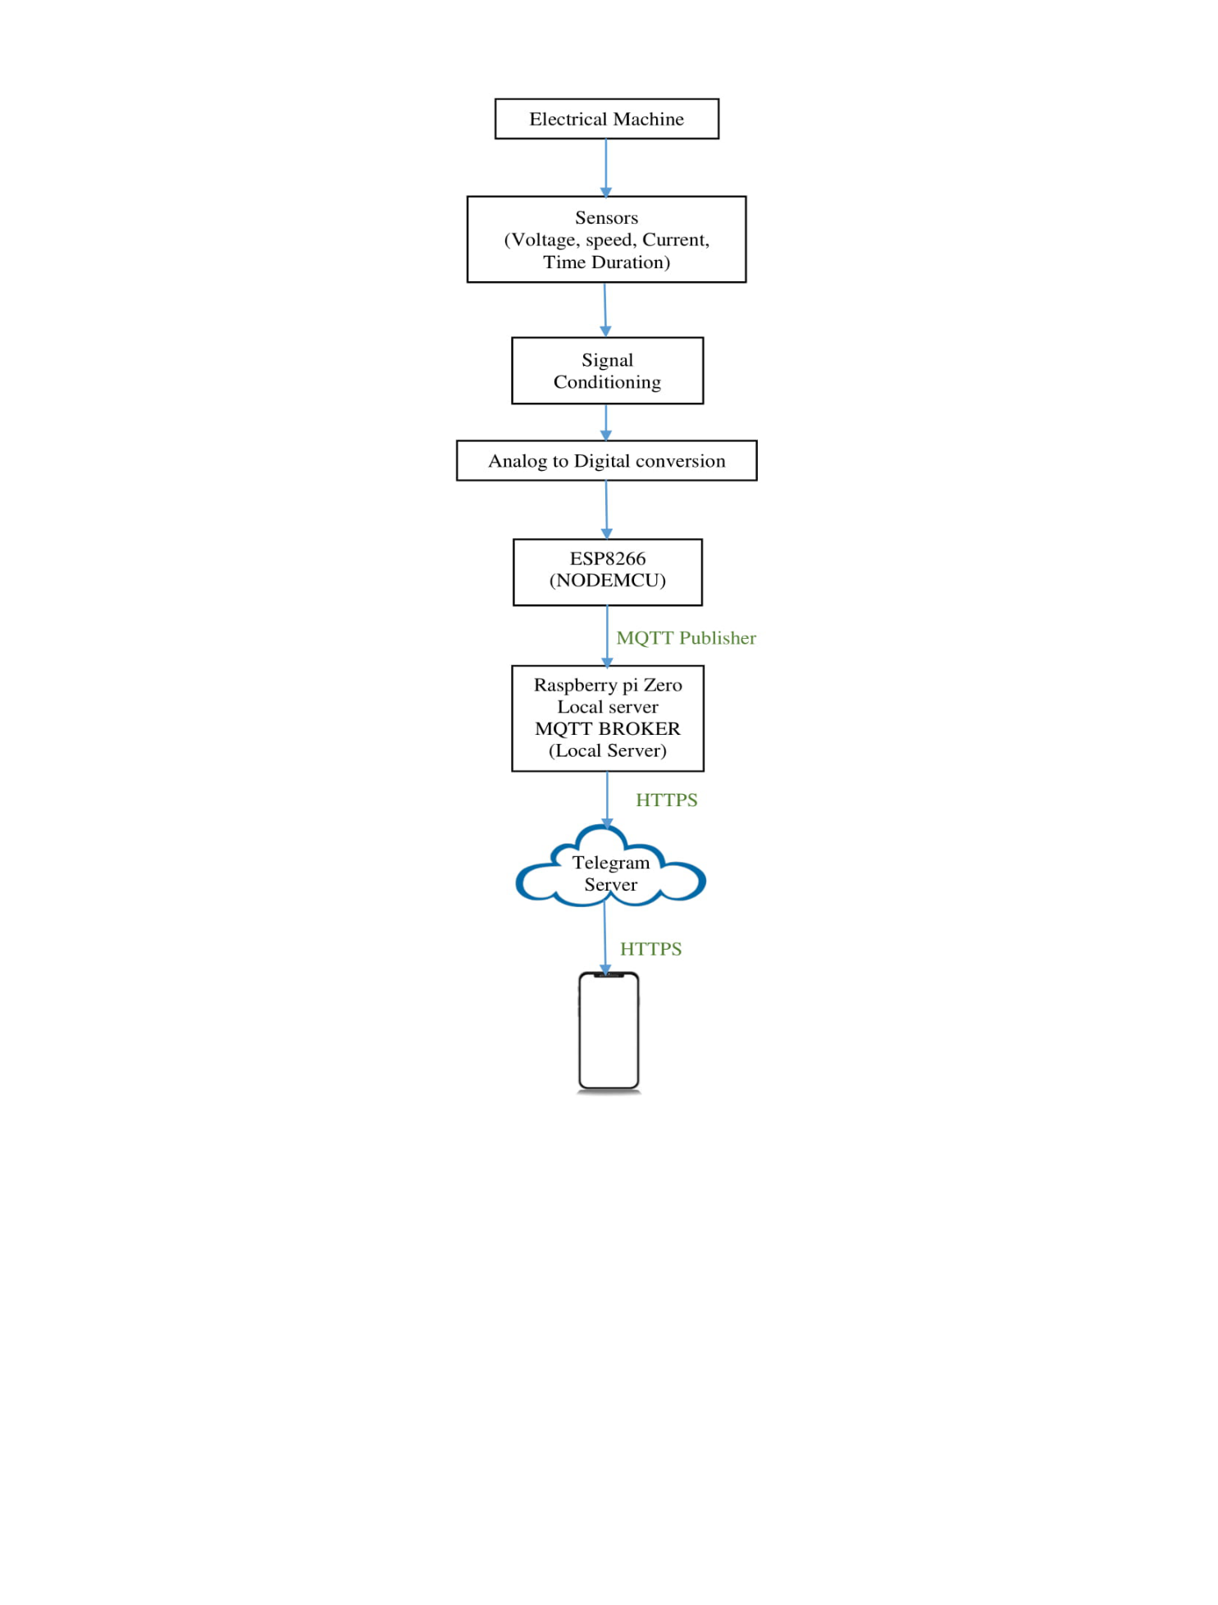

Fig. 5 System Workflow

# Results and Discussion

The MQTT connections are established between the NodeMCU board and the Raspberry Pi Linux computer. The Telegram program is also activated resulting in response in the Chat Bot for the real time viewing of the three phase current and voltage along with the duration of operation and the RPM. The waveforms were captured using Pico scope model 444B. The voltage and the current received in the Telegram Chat Bot is validated using The Agilent 34410A 6½ digit Digital Multimeter. The Figure 6 shows the serial output for acknowledgement of MQTT Connection.

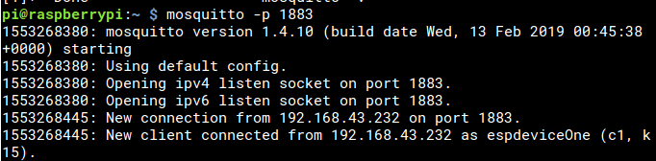

Fig. 6 Serial Output for Acknowledgement of MQTT Connection

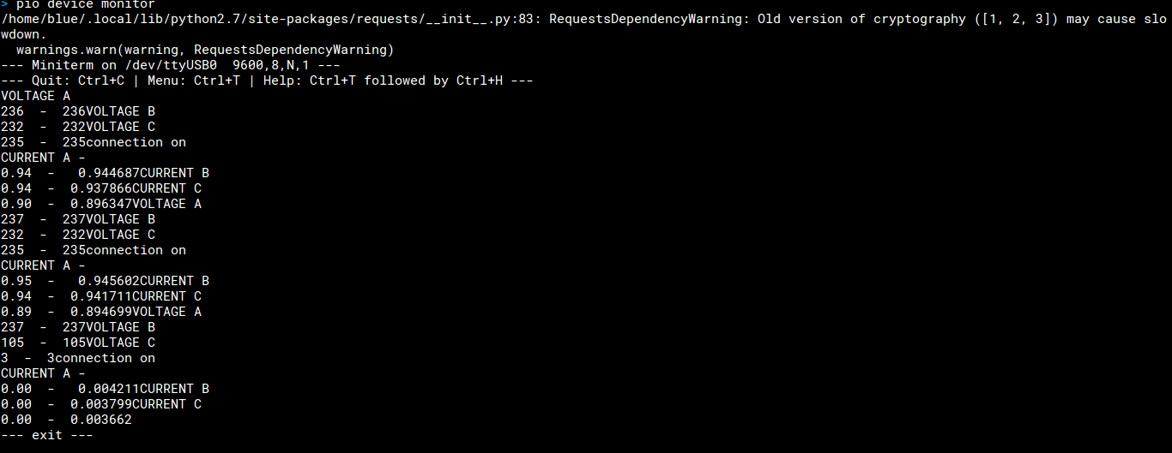

Fig. 7 Serial Output

The three phase current and voltage values are viewed serially from the NodeMCU board in COM1 port set at 9600 baud rate. The three phase current and voltage values are viewed serially from the NodeMCU board in COM1 port which is shown in Figure 7.

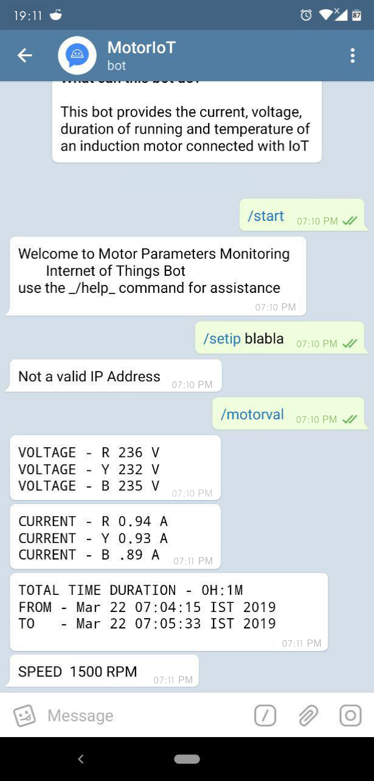

Fig. 8 Parameters displayed in Chat Bot

The Telegram Chat Bot is accessed using a unique Token using an API which stands for Application Programming Interface. Bot commands are used to interact with the Bot. This Bot makes information exchanges and data storage possible [15]. The measured parameters such as the 3 phase current, 3 phase voltage along with duration of operation and speed are displayed in the Chat Bot upon the request from the user at that moment. The output is shown in Figure 8.

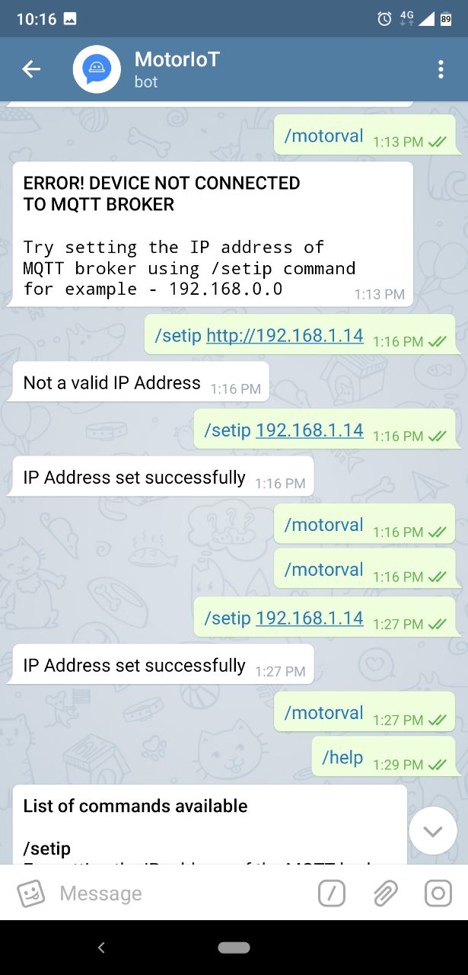

Fig. 9 Output for setip Command in the Chat Bot

The Chat Bot takes only the valid IP address output and reports error “Not a valid IP Address” if an invalid IP address is entered. The Figure 9 shows the output of setip command in Chat Bot. If the device is not connected to Wi-Fi or if the broker is not enabled in the Raspberry Pi then upon the use of “motorval” command an error message pops up saying “ERROR! DEVICE NOT CONNECTED TO MQTT BROKER”. The Figure 10 shows the error output when the device is not connected to MQTT Broker.

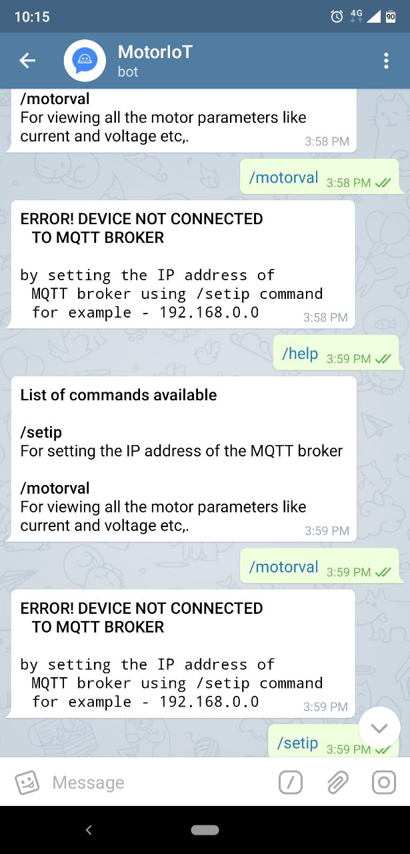

Fig. 10 Error output for device not connected to MQTT Broker

The Chat Bot logs the 3 phase current and voltage of the motor at the moment along with time and date in CSV format. Upon using the “report” command, the logged report is sent to user through the Chat Bot which is shown in Figure 11. The graphical representation of the current and voltage can be done by the user using the Excel formulas [14]. The Chat Bot reports an error every one minute if either one or two wires of the three phase supply to the motor has loose connections. The error will be stopped only when the fault is rectified. With the “settime” command the duration of the operation can be set in terms of minutes. If the motor runs beyond that duration assigned in the “settime” then an alert is pops up in the Chat Bot every one minute. The “settime” value can be reset to reset the alert. The duration can be set in hours to which the motor can be operated in maximum limit.

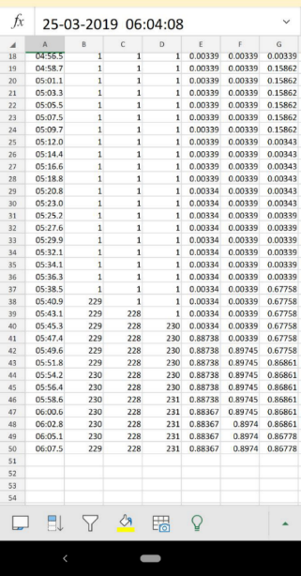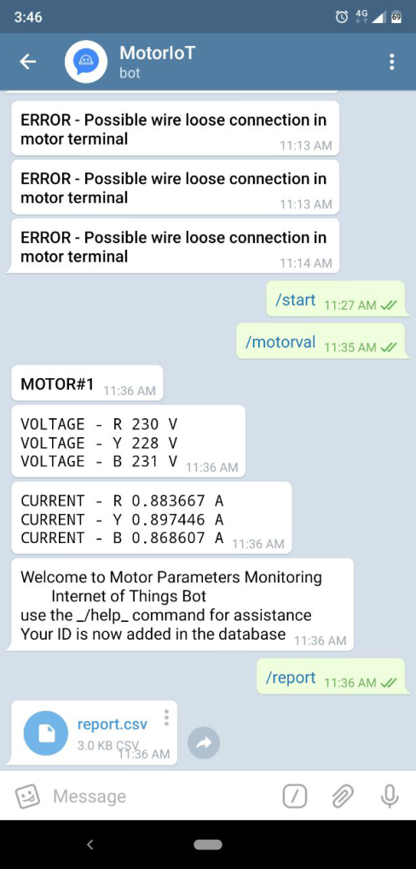

Fig. 11 Screenshot of the telegram with report.csv and the actual report along with error

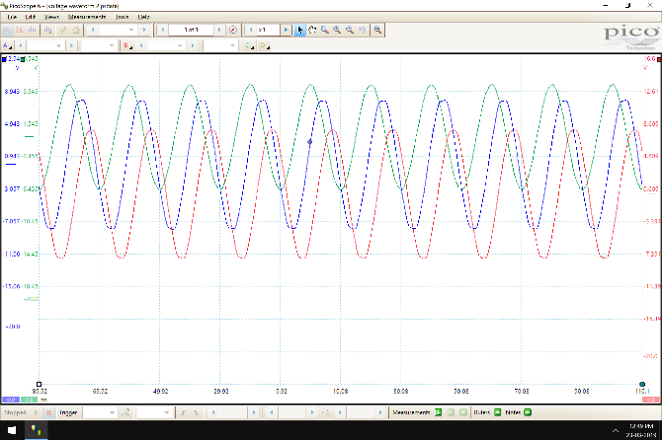

Fig. 12 Voltage waveform of 3 phase Potential Transformer Output

Figure 12 shows the output voltage of the 3 potential transformer used to measure the 3 phase voltage of the motor. From the oscilloscope graph, it can be clearly seen that the voltage are displaced 120 degrees apart with almost the same magnitude.



Fig. 13 Current transformer waveform of 3 phase Potential Transformer Output

The output of the three current transformer used to measure the 3 phase current output of the motor is a voltage. This voltage is measured across the burden resistor of 100 Ohms. The waveform output of the current transformers are displaced 120 degrees from each. The output voltage from both the current transformer and the voltage transformer are set to 200 mV when peak values of measurements are reached. Figure 13 shows the Voltage waveform of 3 phase Current Transformer Output.



Fig. 14 Mux Switching Waveform

The multiplexer switching is done with two second delay and that is observed in the switching input received from the microcontroller. Figure 14 shows the waveform for that switching.



Fig. 15 Comparison of Precision Rectifier Output with Input

The output of the precision rectification circuit is DC waveform. Figure 15 shows the comparison of the input AC signal and the output of the rectifier. The magnitude of AC signal (peak-peak) and DC is same here and can be observed in the waveform.

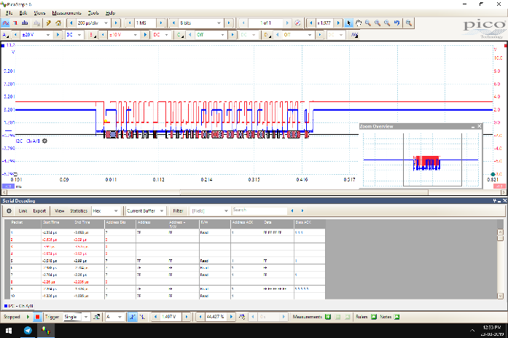

Fig. 16 Waveform for I2C communication with ADS1115 Analog to Digital converter

The Figure 16 shows the waveform for I2C communication with ADS1115 analog to digital converter and the Figure 17 shows the prototype for the proposed project.

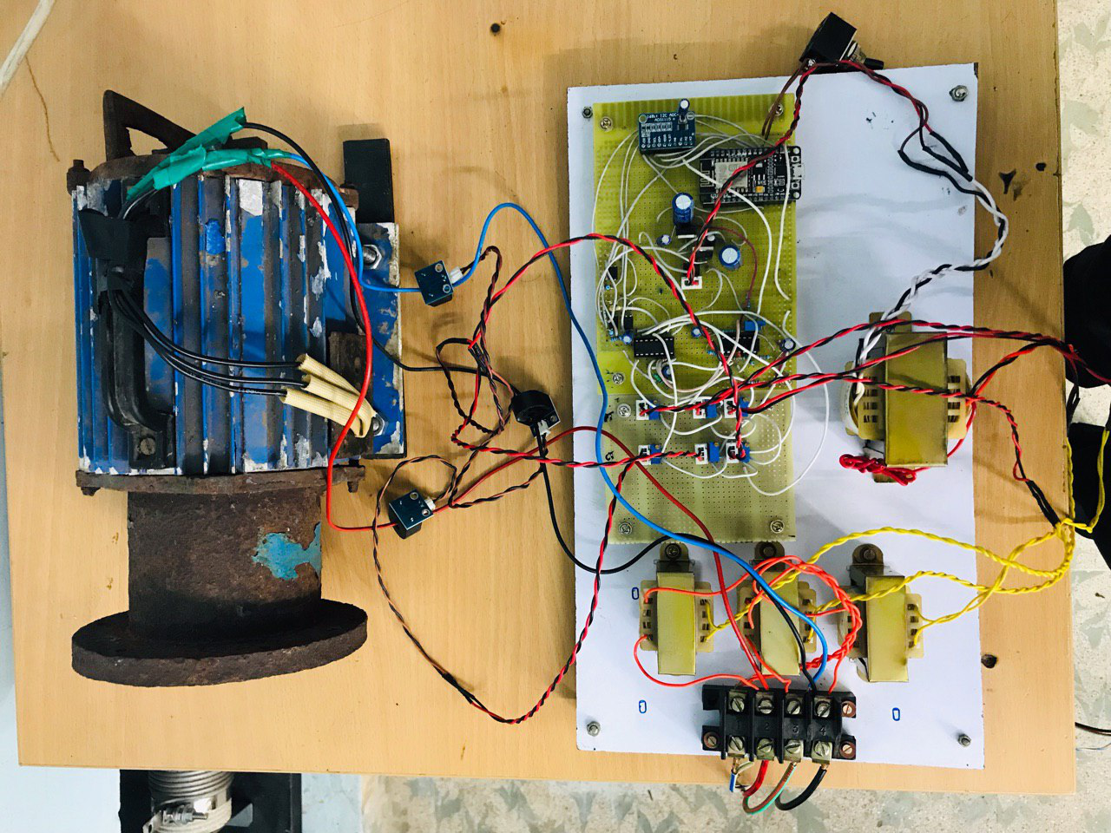

Fig. 17 Picture of the Project with Motor Connected

# Conclusion

The developed system allowed the displaying of multiple motor parameters in Real Time. The parameters that were monitored include the motor voltage, current, speed and the duration of operation. The parameters were displayed in a mobile Telegram app in order to make them possible to be accessed in various devices that have a web browser. Apart from speed the entire system can be removed and attached to motor of similar rating for monitoring of its electrical parameters with least effort [13]. The designed system is easy to install and scale because the sensors used don’t have complex mechanism and the project uses lightweight MQTT protocol which is also reliable and operates at slow network speed but it is powerful enough to handle multiple devices at once. The data logging operation is done very easily with the system. The data logging system is also very reliable since it is stored in the cloud. The data is also easily shared with other people over the internet in less than few steps. The error and alerting system is also verified in this project.

References

1. Carlos M. S. Rodrigues, Bruno S. L. Castro, “A vision of internet of things in industry 4.0 with Esp8266”, International Journal of Electronics and Communication Engineering and Technology (IJECET), Volume 9, Issue 1, January-February 2018, pp. 1–12,
2. Sen, M., & Kul, B. (2017), “IoT-based wireless induction motor monitoring.”, 2017 XXVI International Scientific Conference Electronics (ET)
3. Adnan Shaout, Brennan Crispin, “Using the MQTT protocol in real time for synchronizing IoT device state”, The International Arab Journal of Information Technology, Vol. 15, No. 3A, Special Issue 2018
4. Kasem Khalil, Khalid Elgazzar, Magdy Bayoumi, “A comparative analysis on resource discovery protocols for the Internet of Things”, 2018 Institute of Electrical and Electronics Engineers.
5. Sevil Ahmed, Andon Topalov, Nikola Shakev (2017) “A robotized wireless sensor network based on MQTT cloud computing”, 2017 IEEE International Workshop of Electronics, Control, Measurement, Signals and Their Application to Mechatronics (ECMSM)
6. Hongyu Pei Breivold, Kristian Sandström, “Internet of Things for industrial automation – challenges and technical solutions”, 2015 IEEE International Conference on Data Science and Data Intensive Systems
7. Hareharan V, Sasikumar M,ChandraKala P, “Efficency monitoring of the three phase induction motor using IoT”, International Journal of Advance Research and Innovative Ideas in Education, Vol-4 Issue-2 2018
8. V.S.D Rekha, Dr. K.Srinivasa Ravi, “Induction motor condition monitoring and controlling based on IoT”, International Journal of Electronics, Electrical and Computational System (IJEECS), Volume 6, Issue 9, September 2017
9. Ms. C. Hemalatha, Mr. R. Nagarajan, P. Suresh, G. Ganesh Shankar, “Brushless DC motor controlled by using Internet of Things”, IJSTE - International Journal of Science Technology & Engineering, Volume 3, Issue 09, March 2017
10. Prof. V.P.Kaduskar, Avinash Jha, Nishchey Midha, Ashwini Kumar, “IoT based speed control of AC induction motor”, International Engineering Research Journal
11. G. Ramya, N. Manjubashini, S. P. Santhoshkumar, “IoT using data protocols: issues and performance”, IJSRD - International Journal for Scientific Research & Development, Vol. 5, Issue 10, 2017
12. Ravi Kishore Kodali, Kopulwar Shishir Mahesh, “A low cost implementation of MQTT using ESP8266”, Institute of Electrical and Electronics Engineers Conference, 2016
13. Heiko Koziolek, Andreas Burger, Jens Doppelhamer, “Self-commissioning Industrial IoT-Systems in Process Automation: a Reference Architecture”, 2018 IEEE International Conference on Software Architecture
14. Elias M. Pinheiro, Sérgio D. Correia, “Software model for a low-cost, iot oriented energy monitoring platform”, SSRG International Journal of Computer Science and Engineering ( SSRG – IJCSE ), Volume 5, Issue 7, July 2018
15. Li Da Xu, Wu He, Shancang Li (2014) “Internet of Things in industries: a survey”, IEEE Transactions On Industrial Informatics, Vol. 10, No. 4, November 2014
16. Dr. Bharati Wukkadada , Dr. Kirti Wankhede, Mr. Ramith Nambiar, Ms. Amala Nair, “Comparison with HTTP and MQTT In Internet of Things (IoT)” , Proceedings of the International Conference on Inventive Research in Computing Applications (ICIRCA 2018)
17. Komal S. Shinde, Prachi H. Bhagat, “Industrial process monitoring using IoT”, International conference on I-SMAC, IoT in Social, Mobile, Analytics and Cloud ,I-SMAC 2017.
18. A.Ajitha, J.Laxmi Prasanna, D.Swathi, D.Shyamala, “IoT platform for Condition Monitoring of Industrial Motors”, Proceedings of the 2nd International Conference on Communication and Electronics Systems (ICCES 2017).
19. Santi Nuratch, “Applying the mqtt protocol on embedded system for smart sensors/actuators and IoT applications”, 2018 15th International Conference on Electrical Engineering/Electronics, Computer, Telecommunications and Information Technology.
20. Padlan Alqinsi, Nanang Ismail, Ian Joseph Matheus Edward, Wahyudin Darmalaksana, “IoT-Based UPS monitoring system using MQTT protocols”, 2018 Institute of Electrical and Electronics Engineers.
21. Hansa Lysander Manohar, T. Reuban Gnana Asir, “Data consumption pattern of MQTT protocol for IoT applications”, ICIIT 2017, CCIS 808, pp. 12–22, 2018

1.